NAME : asim sultan
REG : 9008
Lab Tasks
users:
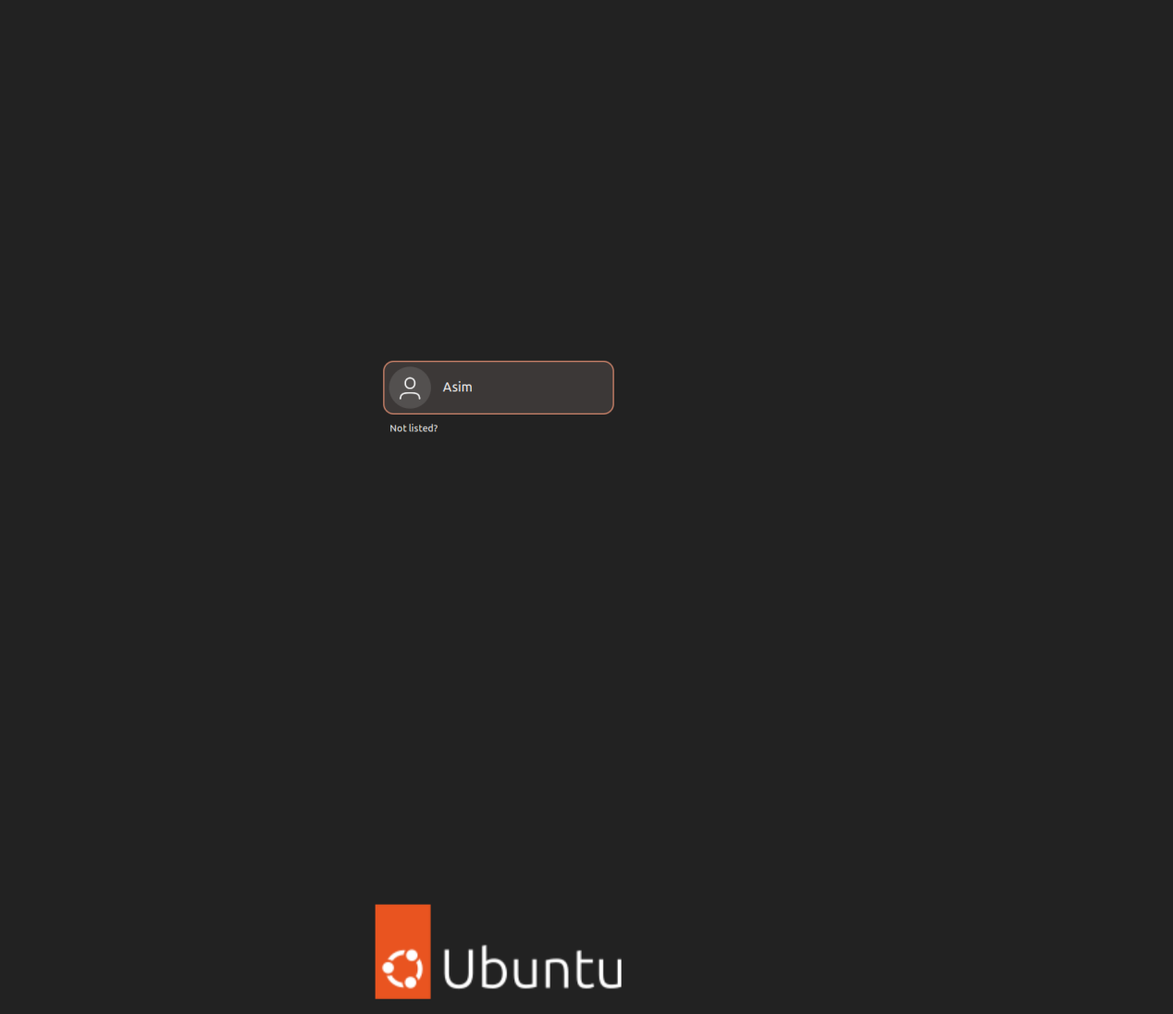

files and folders:
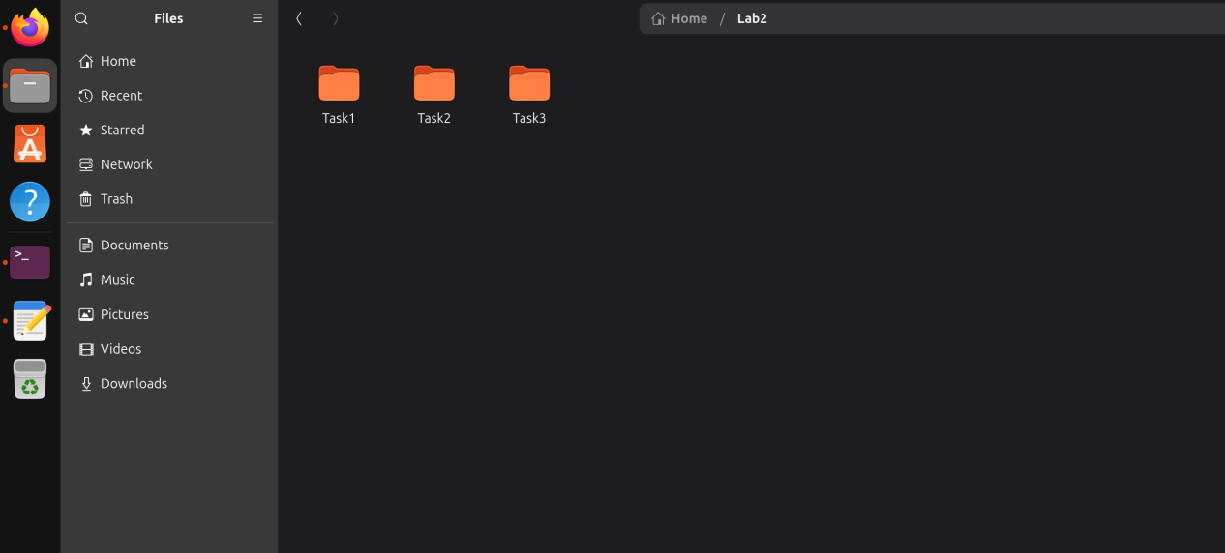

Task 1
Write a C++ program which takes the width & length of Rectangle from the user. Display area and perimeter of Rectangle. Use Makefile to execute your code via Terminal.
Screen Shots
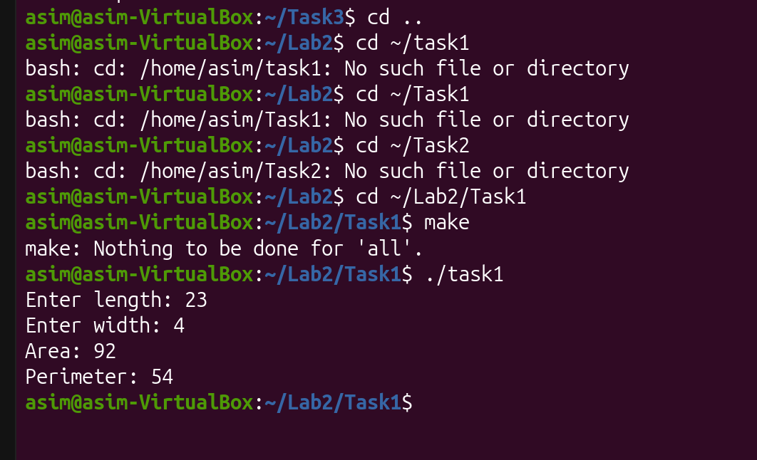

Task 2
A software company sells a package that retails for $199. Quantity discounts are given according to the following table.
Quantity | Discount
1-50 | No discount
Otherwise | 20%
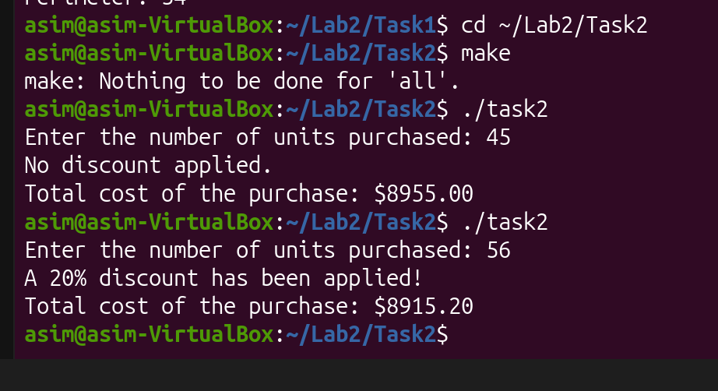

Task 3 (20 marks)
Create a class called Date that includes three pieces of information as data members; a month (type int), a day (type int), and a year (type int). Your class should have three constructors that initialize the three data members. For the purpose of this exercise, assume that the values provided for the year and day are correct, but ensure that the month value is in the range 1-12; if it isn’t, set the month to 1.
Provide setter and getter methods for each data member. Provide a member function displayDate() that displays the month, day and year in the provided format, i.e. day – month – year.
You need to create a header file, i.e. Date.h, which contains specification of class, creates another file Data.cpp which contains all the implementations/definitions of methods available in the class. Write a test program that demonstrates class Date’s capabilities. Use Makefile to execute your code via Terminal.
